System Analysis and Design

FEASIBILITY ANALYSIS

Feasibility analysis guides the organization in determining whether to proceed with the project.

Feasibility analysis also identifies the important risks associated with the project that must be managed if the project is approved.

Each organization has its own process and format for the feasibility analysis, but most include techniques to assess three areas: **Technical Feasibility, Economic Feasibility, and Organizational Feasibility.**

Most project teams revise the feasibility study throughout the SDLC and revisit its contents at various checkpoints during the project. If at any point the project’s risks and limitations outweigh its benefits, the project team may decide to **cancel the project** or **make substantial revisions**.

صورة تحتوي على نص

تم إنشاء الوصف تلقائياً

**Technical Feasibility**

The extent to which the system can be successfully **designed, developed, and installed by the IT group**. Technical feasibility analysis is, in essence, a **technical risk analysis that strives to answer the question: “Can we build it?”**

1. **Users’ and Analysts’ familiarity with the application:**

When analysts are unfamiliar with the business application area, they have a greater chance of misunderstanding the users or missing opportunities for improvement. The risks increase dramatically when the users themselves have limited knowledge of the application. If the project involves a new business innovation, neither the users nor the analysts may have any direct knowledge or experience of the proposed new application. **In general, the development of new systems is riskier than extensions to an existing system, because existing systems tend to be better understood.**

1. **Familiarity with the technology**

Is another important source of technical risk. **When a system uses technology that has not been used before within the organization**, there is a greater chance that problems and delays will occur because of the need to learn how to use the technology. **Risk increases dramatically when the technology itself is new** **(e.g., a Big Data project using Hadoop)**. When the technology is not new, but the organization lacks experience with it, technical risk is reduced somewhat, since outside expertise should be available from vendors and consultants.

1. **Project size**

Is an important consideration, whether measured as **the number of people on the development team, the length of time it will take to complete the project, or the number of distinct features in the system**. Larger projects present more risk, because they are more complicated to manage and because there is a greater chance that some important system requirements will be misunderstood.

1. **Compatibility**

Project teams need to consider the compatibility of the new system with the technology that already exists in the organization. Systems are rarely built in a vacuum—they are built in organizations that have numerous systems already in place. New technology and applications need to be able to integrate with the existing environment for many reasons. They may rely on data from existing systems, they may produce data that feed other applications, and they may have to use the company’s existing communications infrastructure.

**Economic Feasibility “Cost–Benefit analysis”**

This attempts to answer the question “Should we build the system?”

Is determined by identifying costs and benefits associated with the system, assigning values to them, calculating future cash flows, and measuring the financial worthiness of the project. As a result of this analysis, the financial opportunities and risks of the project can be understood

1. **Cash Flow Analysis and Measures**

**Return on Investment**

The return on investment (ROI) is a calculation that measures the average rate of return earned on the money invested in the project. ROI is a simple calculation that divides the project’s net benefits (total benefits – total costs) by the total costs. The ROI formula is

صورة تحتوي على نص

تم إنشاء الوصف تلقائياً

A high ROI suggests that the project’s benefits far outweigh the project’s cost,

**Break-Even Point**

Another common approach to measuring a project’s worth is the break-even point. The break-even point (also called the payback method) is **defined as the number of years it takes a firm to recover its original investment in the project from net cash flows**. As shown in row 4 of Figure 1-8, the project’s cumulative cash flow figure becomes positive during Year 3, so the initial investment is “paid back” over two years plus some fraction of the third year.

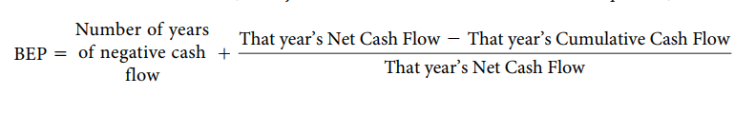

صورة تحتوي على منضدة

تم إنشاء الوصف تلقائياً

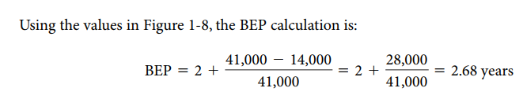

**Discounted Cash Flow Technique**

Discounted cash flows are used to **compare the present value of all cash inflows and outflows for the project in today’s dollar terms**. The key to understand **present values** is to **recognize that if you had a dollar today, you could invest it and receive some rate of return on your investment**. Therefore, a dollar received in the future is worth less than a dollar received today, since you forgot that potential return. If you have a friend who owes you $100 today, but instead gives you that $100 in 3 years—you’ve been had! Assuming you could have invested those dollars at a 10% rate of return, you will be receiving the equivalent of $75 in today’s terms. The basic formula to convert a future cash flow to its present value is

صورة تحتوي على نص

تم إنشاء الوصف تلقائياً

**The rate of return** used **in the present value calculation is sometimes called the required rate of return, or the cost of obtaining the capital needed to fund the project**., $100 received in 3 years with a required rate of return of 10% has a PV of $75.13

صورة تحتوي على نص

تم إنشاء الوصف تلقائياً

صورة تحتوي على منضدة

تم إنشاء الوصف تلقائياً

**Net Present Value (NPV)**

The NPV is simply the difference between **the total present value of the benefits and the total present value of the costs.**

صورة تحتوي على نص

تم إنشاء الوصف تلقائياً

If the NPV is greater than zero, the project is considered economically acceptable. Unfortunately for this project, the NPV is less than zero, indicating that for a required rate of return of 10%, this project should not be accepted. The required rate of return would have to be something less than 6.65% before this project returns a positive NPV. This example illustrates the fact that sometimes the “naïve” techniques of ROI and BEP find that the project appears acceptable, but the more rigorous and financially correct NPV technique finds the project is unacceptable.

**Identify Costs and Benefits**

The systems analyst’s first task when developing an **economic feasibility analysis** is to identify the kinds of costs and benefits the system will have and list them along the left-hand column of a spreadsheet.

صورة تحتوي على نص

تم إنشاء الوصف تلقائياً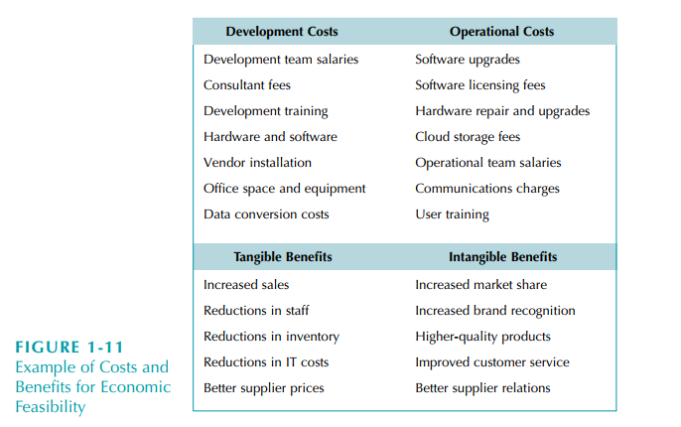

Figure 1-11 lists examples of costs and benefits that may be included. The costs and benefits can be broken down into four categories: (1) development costs, (2) operational costs, (3) tangible benefits, and (4) intangibles benefits.

صورة تحتوي على منضدة

تم إنشاء الوصف تلقائياً

صورة تحتوي على منضدة

تم إنشاء الوصف تلقائياً

* **Assignments**
* **Create the Feasibility study of your course project.**

**You must include Technical, and Economic feasibility.**

**Calculate the ROI, NPV, and BEP**